**Model Development Phase -**

|  |  |
| --- | --- |
| Date | 21 JUNE 2025 |
| Team ID | SWTID1749896042 |
| Project Title | Unemployed Insurance Beneficiary Forecasting |
| Maximum Marks | 4 Marks |

**Initial Model Training Code, Model Validation and Evaluation Report**

The initial model training code will be showcased in the future through a screenshot. The model validation and evaluation report will include classification reports, accuracy, and confusion matrices for multiple models, presented through respective screenshots.

**Initial Model Training Code:**

#importing and building the ARIMA model

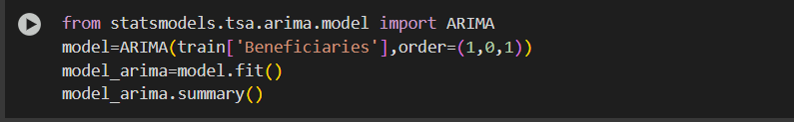

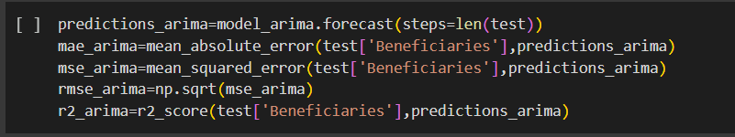

#importing and building the SARIMA model

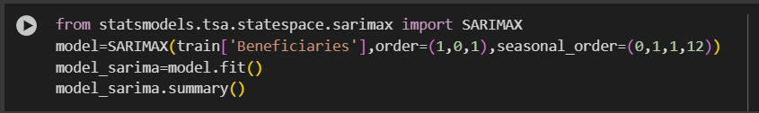

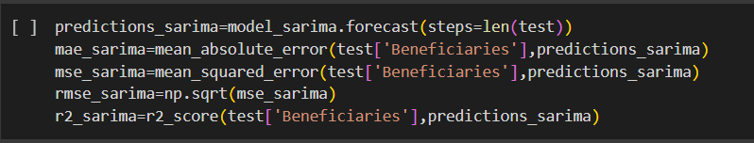

#importing and building the AutoReg model

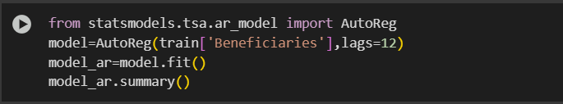

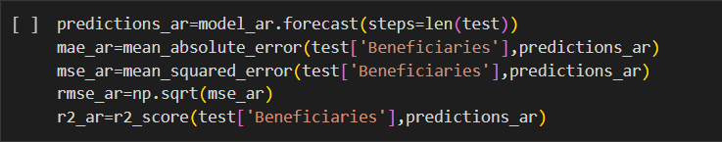

#importing and building the VAR (Vector AutoRegression) model

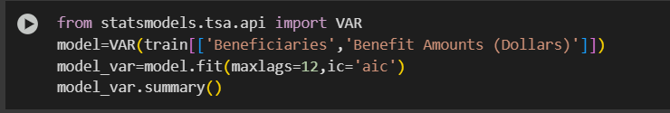

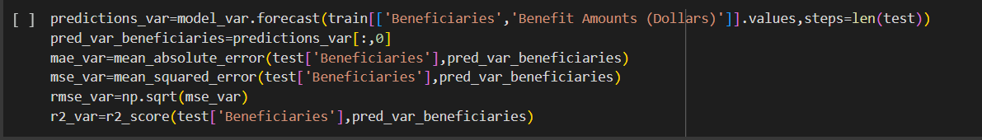

#importing and building the Prophet model

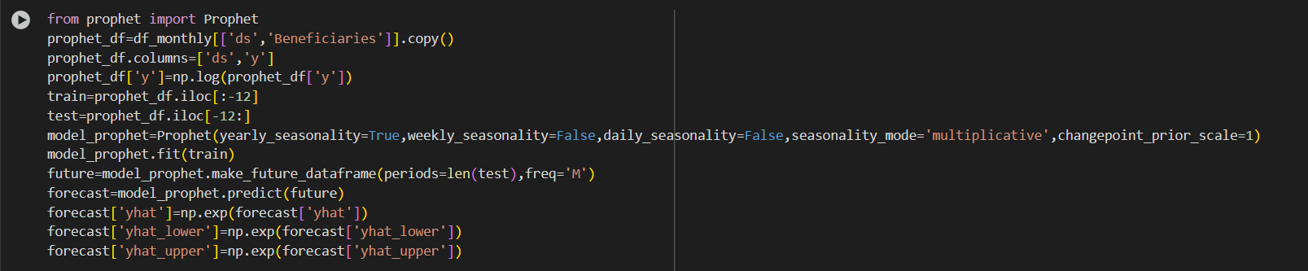

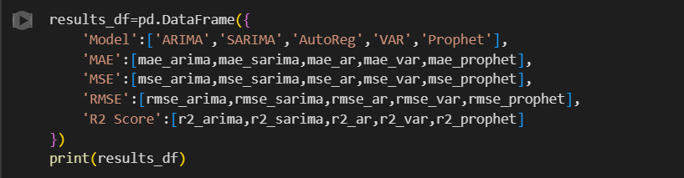

**Model Validation and Evaluation Report:**

**NOTE - "Since the objective of this project was to forecast the number of unemployment insurance beneficiaries over time, it focused on time series regression rather than classification. Therefore, classification metrics like precision, recall, and confusion matrix were not applicable."**

|  |  |  |  |
| --- | --- | --- | --- |
| **Model** | **Classification Report** | **F1**  **Scor e** | **Confusion Matrix** |
| **ARIMA** | **NA** | **-** | **NA** |
| **SARIMA** | **NA** | **-** | **NA** |
| **AutoReg** | **NA** | **-** | **NA** |
| **VAR** | **NA** | **-** | **NA** |
| **PROPHET** | **NA** | **-** | **NA** |